

SUBMITTED BY
MARUF HASAN SHUVO
Roll: 250 10 20 22
Dept: CSE

SUBMITTED TO
MD MAHBUB E NOOR
Dept: Computer Science & Engineering

YAMAHA MOTORCYCLES SALES ANALYSIS & CUTOMER INSIGHTS

EXECUTIVE SUMMARY
This project analyzes Yamaha motorcycle sales and customer insights using Microsoft Excel dashboards to assess business performance and customer behavior through data visualization.
A dataset of over 1,200 records was compiled, capturing details such as bike models, price, division, customer age group, occupation, payment type, color preference, and ratings. Two interactive dashboards were developed: one for sales performance and another for customer insights.
The sales dashboard highlights key metrics such as total sales, revenue, cost, and profit, along with model-wise and division-wise performance. The customer dashboard provides insights into customer demographics, preferences, and satisfaction levels.
Overall, this project demonstrates how Excel can be used as a powerful tool for data analysis and decision-making. The findings from this project can help businesses improve their strategies and better understand their customers.

Table of Contents
EXECUTIVE SUMMARY 2
INTRODUCTION 5
MOTORCYCLE MODELS OVERVIWE 6
Yamaha FZS-V2: 6
Yamaha FZS-V3: 6
Yamaha FAZER: 7
Yamaha MT-15 : 7
YAMAHA R15 : 8
Yamaha Ray zr : 9
METHODOLOGY 9
Data Collection : 9
Data Cleaning and Preparation : 10
Analytical Tools and Techniques : 10
Visualization : 10
DATA ANALYSIS & FINDINGS 11
Sales & Business overview (dashboard 1) 12
KPI Overview : 12
Model-wise Sales Analysis : 12
Division-wise Sales Analysis : 12
Sales Trend Analysis : 12
Payment Method : 12
Slicer Functionality : 12
customer insights (dashboard 2) 12
Age Group Analysis : 12
Occupation Analysis : 12
Color Preference Analysis : 12
Purchase Purpose Analysis : 12
Customer Rating Analysis : 12
Service Experience Analysis : 12
Slicer Functionality : 12
combined analysis 12
Sales Vs Customer Behavior : 12
Model Popularity vs Customer Preference : 12
Regional Sales vs Customer Type : 12
Business insight Summary : 12
RECOMMENDATIONS 13
CONCLUSION 13
APPENDIX 13
REFERENCE 13

INTRODUCTION

In today's data-driven world, understanding business performance and customer behavior is crucial for making smart decisions. This project looks at motorcycle sales and customer insights for Yamaha Motor Company using Microsoft Excel.


Yamaha Motor Company is one of the top motorcycle makers globally, known for its innovation, performance, and stylish designs. In Bangladesh, Yamaha has become popular, especially among young riders, thanks to its modern sports bikes like the R15, FZS series, and MT-15.

The main goal of this project is to analyze sales trends and understand customer preferences using a structured dataset. We created a dataset with over 1,200 records, including details like bike model, price, division, sales date, payment type, customer age group, occupation, color preference, purchase purpose, and satisfaction rating.

With this dataset, we developed two interactive dashboards in Microsoft Excel. The first dashboard examines business performance, including total sales, revenue, costs, and profit analysis. The second dashboard looks at customer insights, such as age group distribution, occupation, preferences, and satisfaction levels.

We utilized a range of Excel tools, including Pivot Tables, Pivot Charts, Slicers, and KPI indicators, to effectively summarize and visualize the data. By doing so, we created interactive dashboards that enable users to engage with the data and quickly obtain valuable insights, making it easier for them to understand and make informed decisions. These dashboards are designed to be user-friendly, allowing users to easily navigate and analyze the data, and gain a deeper understanding of the information being presented.

Overall, this project shows how Microsoft Excel can serve as a powerful tool for data analysis and visualization, helping businesses understand their performance and customer behavior for better decision-making.

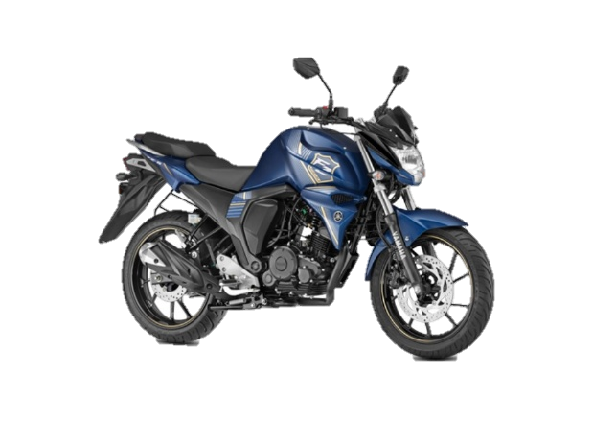
MOTORCYCLE MODELS OVERVIWE
Yamaha FZS-V2: The Yamaha FZS V2, also known as the FZ-S FI Version 2.0, is a 149cc, fuel-injected street-naked motorcycle recognized for its strong design, smooth engine, and balanced handling. This model is a major update to the original FZ16, focusing on fuel efficiency through Blue Core Technology rather than sheer power. This makes it a favorite commuter bike in its class.

Key Aspects of the FZS V2:
• Engine & Performance: It features a 149cc, single-cylinder, air-cooled, 4-stroke engine with 2 valves and a SOHC design. This engine produces around 13.0 to 13.2 Bhp at 8000 rpm and 12.8 Nm of torque at 6000 rpm.
• Fuel Injection (FI): The main upgrade for this model is the Fuel Injection system. It boosts fuel efficiency by about 14% compared to the carburetor version and offers smoother acceleration.
• Mileage & Speed: Users typically report a mileage of 40-45 kmpl in city riding and up to 45-50 kmpl on highways. The top speed is usually around 115-120 kmph.
• Design & Comfort: The motorcycle has a strong design with a 12-liter fuel tank, a split-seat setup for better comfort for both rider and pillion, and a digital instrument cluster.
• Braking & Suspension: The newer models with Double Disc (DD) have a 282 mm front disc and a 220 mm rear disc brake for solid stopping power. They come with telescopic front forks and a mono-shock rear suspension, providing good balance.
• Weight & Handling: Weighing about 132-133 kg, it is relatively light, making it agile and easy to manage in city traffic.
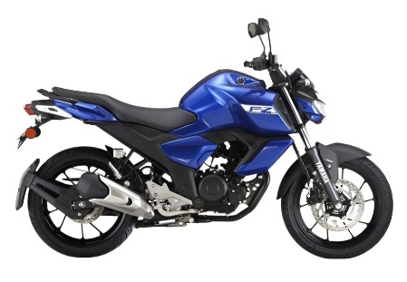
Yamaha FZS-V3: The Yamaha FZS-FI V3 is a 149cc, fuel-injected streetfighter designed for comfortable commuting. It has a 4-stroke, SOHC, 2-valve "Blue Core" engine that produces about 12.4 to 13 PS and 12.8 to 13.3 Nm of torque. The bike includes front single-channel ABS, LED headlights, a negative LCD console, and a strong design with an upright, comfortable riding position.

Key Features and Overview:
Engine Performance: The 149 cc air-cooled engine provides better low-end torque, ensuring smooth acceleration for city traffic instead of high-speed highway racing.
Design & Comfort: It has a robust fuel tank with shrouds, a single-piece two-level seat that improves pillion comfort, and a high-set handlebar for an upright, relaxed, and ergonomic riding position.
Safety & Technology: The bike comes with single-channel ABS on the front wheel, a side-stand engine cut-off switch for safety, and Bluetooth connectivity via the Yamaha Motorcycle Connect X app in some versions.
Braking & Suspension: It features front and rear disc brakes along with a telescopic fork in the front and a 7-step adjustable mono cross suspension in the rear.
Mileage & Speed: The bike is known to deliver fuel efficiency of about 45 to 50 kmpl. Its top speed is typically reported between 105 and 120 kmph.
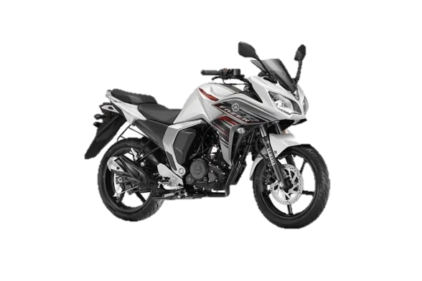
Yamaha FAZER: The Yamaha Fazer is a great bike for long trips, with a comfortable riding position and a unique half-fairing design. It's often seen as a good alternative to the FZ series, but with a more touring-friendly style. The 150cc Fazer FI V2, which is popular in South Asia, has a 149cc engine with fuel injection, gets around 40-45 km per liter, and weighs about 137 kg when full of fuel. This bike is known for being versatile, coming in a range of sizes from 150cc to 600cc, making it a good choice for different types of riders.
Key Features and Performance
Engine & Performance: The 150cc Fazer FI V2 uses a 4-stroke, air-cooled, single-cylinder engine with blue-core technology, producing approximately PS and Nm torque. It is known for smooth acceleration, though it is designed for comfort rather than high-speed racing.
Design & Handling: The defining half-fairing offers some wind protection for longer rides. It shares a similar frame and comfortable seating with the FZ series, making it good for city commuting and light touring.
Fuel Efficiency: Users generally report mileage between 40–45 km/l, with a 12-liter fuel tank providing good range.
Braking & Suspension: The V2 variant typically features a front disc brake and a rear drum brake. The suspension is generally on the softer side to enhance rider comfort.

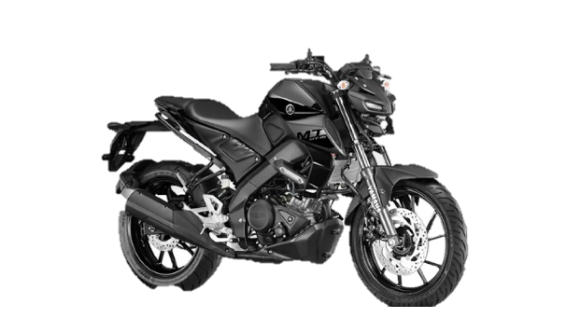
Yamaha MT-15 : The Yamaha MT-15 (Version 2.0/V2) is an aggressive 155cc "hyper naked" streetfighter, known for its agile handling and high-performance, R15-derived engine. It features USD front forks, VVA technology, a 6-speed gearbox with a slipper clutch, and Bluetooth connectivity, making it a popular choice for urban commuting and spirited riding.
Key Features and Highlights:
Engine: 155cc liquid-cooled, 4-stroke, SOHC, 4-valve engine with Variable Valve Actuation (VVA).
This engine puts out around 18.4 horsepower at its peak, which happens when it's running at 10,000 revolutions per minute. It also produces about 14.1 Newton-meters of torque when it's spinning at 7,500 revolutions per minute.
Suspension/Handling: Upside-down (USD) front forks and a linked-type monocross rear suspension.
Safety/Tech: Dual-channel ABS (in many markets), traction control system, and a negative LCD instrument cluster.
Design: Compact "mass-forward" body design with LED headlamps (bi-functional).
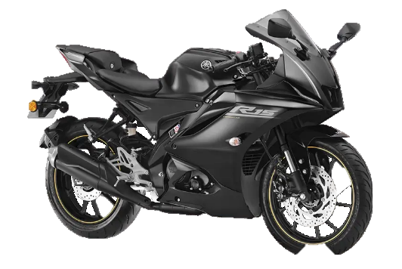
YAMAHA R15 : The 2026 Yamaha R15 (Version 4/M) is a premium 155cc, fully-faired sportbike offering super sports styling, featuring a 18.4 PS liquid-cooled engine, VVA technology, and advanced features like quick shifter, traction control, and USD forks. Known for its sharp handling and racing DNA, it delivers ~40-45 kmpl, making it a popular track-focused commuter.
Key Aspects of the Yamaha R15 V4/M (2026 Model)
Engine Performance: 155.1cc, 4-stroke, SOHC, 4-valve engine with Variable Valve Actuation (VVA) that delivers 18.4 PS at 10,000 RPM and 14.2 Nm of torque at 7,500 RPM.
The bike's design is really sharp and aerodynamic, kind of like the R7. It's got a lot of cool features, including a dual-channel ABS system similar to the R1M, a bright LED headlight, and a sleek fairing that covers the whole bike. Overall, it looks like a powerful and stylish ride.
Technology & Features: Includes a 6-speed gearbox, traction control system, quick shifter (on select variants), and a digital display with smartphone connectivity via the Y-Connect app.
Handling & Braking: Equipped with upside-down (USD) front forks for stability and standard dual-channel ABS (in most markets).
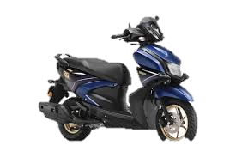
Yamaha Ray zr : The Yamaha Ray ZR 125 Fi Hybrid is a great scooter for city riding, it's really light at just 99 kg and has a powerful 125cc Blue Core engine. What makes it special is the smart motor generator, or SMG, which gives you a boost when you need it, so you can accelerate faster. Plus, it's really good on fuel, with some people getting up to 71 km per liter, which is amazing for a scooter. And when you're out and about, you've got plenty of space to store your stuff, with a big 21-liter compartment under the seat.
Key Features and Specs:
Engine: Air-cooled 125cc engine producing 8.4 bhp and 10.3 Nm of torque.
Hybrid Power Assist: SMG provides a torque boost during acceleration.
Design: Sharp, sporty aesthetic with LED headlight, DRLs, and a "Street Rally" variant option.
Technology: Includes Bluetooth connectivity, a digital instrument cluster, and a silent starter system.
Performance: 12-inch front alloy wheel, 190 mm front disc brake (on higher variants), and telescopic suspension.

METHODOLOGY
The methodology adopted in this project was designed to ensure a systematic and accurate analysis of Yamaha motorcycle sales and customer data. The process involved several stages, including data collection, data cleaning, analysis, and visualization. Each step played an important role in transforming raw data into meaningful insights.
The primary tool used for this project was Microsoft Excel, which provides powerful features for data analysis and dashboard creation. The entire workflow was carefully organized to maintain clarity, accuracy, and efficiency throughout the project.
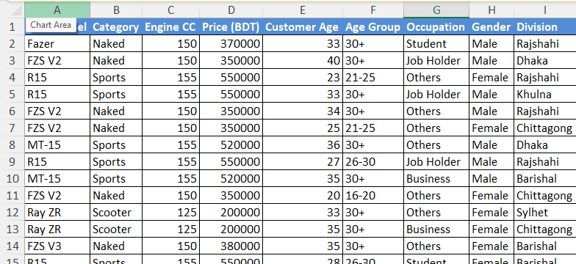
Data Collection : The data used in this project was manually created to simulate real- world sales scenarios of Yamaha motorcycles. A dataset containing more than 1200 rows was prepared, including various attributes such as bike model, price, division, date of purchase, payment type, customer age group, occupation, color preference, purchase purpose, and customer rating . This dataset was designed to represent realistic business data, allowing meaningful analysis of both sale performance and customer behavior.

Data Cleaning and Preparation : Before analysis, the dataset was carefully cleaned and prepared. Missing or inconsistent values were checked and corrected to ensure data accuracy. Data types such as numbers, text, and dates were properly formatted.
The data was organized into an Excel Table, making it easier to work with and analyze. This format allows for dynamic handling of the data, and it's simpler to apply formulas, filters, and pivot tables. By structuring the data properly, we were able to avoid errors and make the analysis process much smoother.
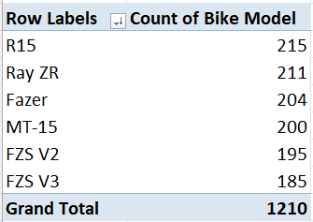
Analytical Tools and Techniques :
Microsoft Excel was used as the main analytical tool in this project. Pivot Tables were created to summarize large amounts of data into meaningful insights. These pivot tables helped analyze sales by model, division, age group, and other categories.
Pivot Charts were used to visually represent the summarized data, making it easier to understand patterns and trends. Various calculations such as total sales, revenue, cost, and profit were performed using Excel formulas.
To make the dashboards more interactive, slicers were added, which let users filter the data in different ways, depending on what they need to see. This makes it easier for them to get the information they want, by selecting specific criteria to focus on.
Visualization : In this project, data visualization was really important. We used a lot of different charts like bar charts, column charts, pie charts, and donut charts to make the data easy to understand and look nice. This helped us show the information in a way that was clear and simple to see. By using these different types of charts, we could make the data more interesting and easier to grasp, which was a big part of making the project successful.
We made two special dashboards that help us see how things are going. One is for sales and how the business is doing, and the other is for understanding our customers better. We also added some important boxes that show us key numbers, like how much we sold, how much money we made, and how much profit we got. These boxes are called KPIs, which stands for Key Performance Indicators, and they help us keep an eye on the things that matter most.
The use of slicers made the dashboards interactive, enabling users to explore the data easily and gain deeper insights.

DATA ANALYSIS & FINDINGS

Sales & Business overview (dashboard 1)
KPI Overview :
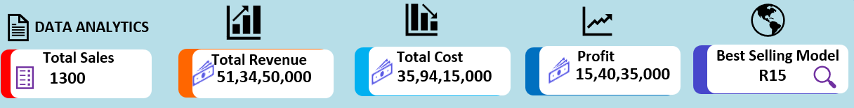
The business performance can be seen at a glance in the KPI section. This is where you find the main points that show how well the business is doing, like how much is being sold, how much money is coming in, what the total costs are, and what the profit is. These numbers help figure out if the business is running smoothly or not. By looking at these key indicators, you can get a sense of whether things are going well or if changes need to be made. The company's financial results show that it's making a good amount of money and keeping costs under control, which is a great sign of how well the business is doing. This suggests that the company is in a strong position and things are going well.

Model-wise Sales Analysis :
This analysis shows the sales distribution among different motorcycle models. It helps identify which models are most preferred by customers. The data indicates that sports and commuter bikes such as Yamaha R15, FZS series, and MT-15 have higher demand compared to other models. This suggests that customers prefer stylish and performance-oriented bikes.

Division-wise Sales Analysis :
This section analyzes sales performance across different geographical regions. It helps to identify high-performing and low-performing divisions. It turns out that cities tend to have more bike sales than rural areas, and this is because people in cities generally have more money to spend and are looking for higher-end bikes.

Sales Trend Analysis :
Sales trend analysis helps to understand how sales change over time. It shows monthly or yearly performance patterns. The trend indicates fluctuations in sales, with some months showing higher demand due to seasonal effects and promotional activities.

Payment Method :
This analysis compares different payment methods such as cash and EMI. It helps understand customer payment behavior. The data shows that EMI is becoming increasingly popular, as it allows customers to purchase expensive bikes more easily.

Slicer Functionality :
Slicers are used to make the dashboard interactive. They allow users to filter data based on categories such as bike model, division, and payment type. This makes the analysis more flexible and user-friendly. 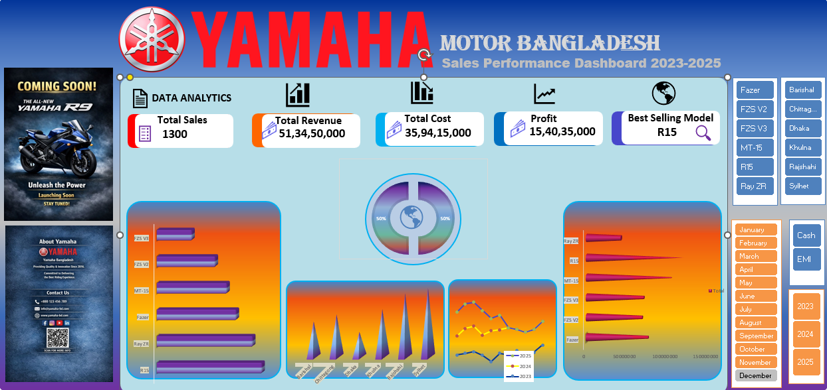

customer insights (dashboard 2)

Age Group Analysis :
This section analyzes the age distribution of customers. It helps identify the target customer segment .The analysis shows that young customers dominate the motorcycle market, especially in the sports bike category.

Occupation Analysis :
This analysis shows the occupation of customers such as students, job holders, and business persons. It helps understand the economic background of buyers . The data indicates that students and young professionals are the primary customers.

Color Preference Analysis :
This section highlights customer preferences regarding motorcycle colors .It is observed that darker and sporty colors are more popular among young riders.

Purchase Purpose Analysis :
This analysis explains why customers purchase motorcycles, such as personal use, commuting, or business purposes .People usually purchase bicycles for getting around town and as a way to get from one place to another on a daily basis.

Customer Rating Analysis :
Customer ratings help measure satisfaction levels. Higher ratings indicate better customer experience and product satisfaction .The analysis shows that most customers give positive ratings, indicating good service quality.

Service Experience Analysis :
This section evaluates after-sales service quality based on customer feedback .Good service experience leads to higher customer satisfaction and repeat purchases.

Slicer Functionality :
Slicers are used here to filter customer data dynamically. Users can easily analyze specific groups based on age, occupation, or preferences.
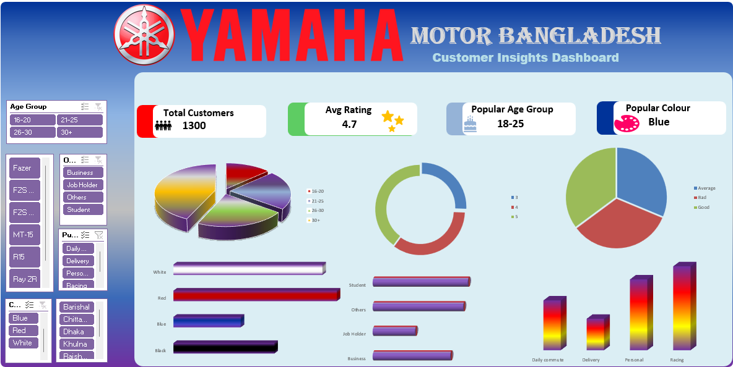

combined analysis

Sales Vs Customer Behavior :
This analysis connects sales performance with customer behavior. It shows how customer preferences directly impact sales of different motorcycle models.

Model Popularity vs Customer Preference :
This section compares popular models with customer demographics. It helps identify why certain models perform better in the market.

Regional Sales vs Customer Type :
This analysis links regional sales data with customer types, helping to understand which regions have specific customer segments.

Business insight Summary :
When you look at everything together, you get a clear picture of how your business is doing and what your customers are like. This helps you make big decisions that can guide your business towards success in the future.

RECOMMENDATIONS
Based on the analysis of Yamaha motorcycle sales and customer insights, several important recommendations can be made to improve business performance and customer satisfaction.
Firstly, the company should focus more on the youth market. The analysis shows that most customers belong to the young age group, especially students and young professionals. Therefore, Yamaha should design more marketing campaigns targeting this segment through social media, online advertising, and campus-based promotions.
Secondly, popular models such as Yamaha R15, FZS series, and MT-15 should be given more priority in production and marketing. These models show higher demand compared to others, indicating strong customer preference for sporty and stylish bikes.
Thirdly, the company should expand EMI facilities and make installment payment options more flexible. Many customers prefer EMI due to affordability issues, especially students and middle-income groups. Easier EMI options can increase overall sales.
Fourthly, Yamaha should focus on improving sales performance in low-performing regions. Special promotional campaigns, dealership expansion, and customer engagement programs can help increase sales in those areas.
Fifthly, customer satisfaction and after-sales service should be improved. Regular service feedback collection and faster service response can increase customer loyalty and brand trust.
What customers like in terms of color is also important. Some colors are really popular with buyers. So, Yamaha should think about making more bikes in the colors that people want. This could help them sell more bikes and attract new customers.
Finally, data-driven decision-making should be encouraged within the company. By continuously analyzing sales and customer data, Yamaha can better understand market trends and adjust their business strategies accordingly.

CONCLUSION
This project is all about looking at how well Yamaha motorcycles are selling and what customers like. We used Microsoft Excel to make it happen. The main goal was to see how the business is doing and what customers prefer by using pictures and graphs to show the data.
Two interactive dashboards were developed in this project. The first dashboard focused on sales and business performance, including key metrics such as total sales, revenue, cost, and profit. It also provided insights into model-wise performance, regional sales distribution, sales trends, and payment methods.
The second dashboard was all about getting to know our customers better. It showed us things like how old they are, what they do for work, what colors they like, why they buy from us, how happy they are with our products, and how they feel about the service they get. All this information helped us understand what makes our Yamaha customers tick and what they like.
When you look at the big picture, it's easy to see that younger buyers are really driving the market for motorcycles. They especially love the sporty models like the Yamaha R15, FZS, and MT series. Being able to pay in installments and getting good service also makes a big difference - it keeps customers happy and helps sales go up.
The use of Excel tools such as Pivot Tables, Pivot Charts, Slicers, and KPI indicators made the analysis more effective and interactive. These tools helped transform raw data into meaningful insights.
So, what we can take away from this project is that using data to make decisions is really important for businesses today. It helps them sell more, understand what customers want, and make good choices for the future. By looking at data, companies can figure out what's working and what's not, and use that information to make smart decisions that will help them grow. This is a key part of being successful in business, and it's something that all companies should be doing.

APPENDIX
The appendix is where you'll find extra information that helps explain the project. This extra stuff makes it easier to understand the analysis and what we found out, which is all talked about in the main part of the report.
The following items are included in the appendix:
Raw Dataset Sample
A sample of the dataset used in this project, containing information such as bike model, price, division, sales date, customer age group, occupation, payment method, color preference, and customer rating.
Excel Data Table Screenshot
The structured Excel table created after data cleaning and preparation, which was used for Pivot Table analysis.
Pivot Tables
Pivot Tables used for summarizing data, including model-wise sales, division-wise sales, age group analysis, and customer behavior analysis.
Dashboard Screenshots
Full screenshots of both dashboards:
Sales & Business Overview Dashboard (Dashboard 1)
Customer Insights Dashboard (Dashboard 2)
Pivot Charts and Visualizations
Charts such as bar charts, pie charts, line charts, and donut charts used for visual representation of data.
Slicers View
Screenshots of slicers used to make the dashboards interactive and user-friendly . These supporting materials ensure transparency of the analysis process and validate the results presented in the main report.

REFERENCE
The following sources were used to complete this project:
Microsoft Corporation. (n.d.). Microsoft Excel Documentation. Retrieved from https://support.microsoft.com/excel
Microsoft Corporation. (n.d.). Create a PivotTable to analyze worksheet data. Retrieved from https://support.microsoft.com
Microsoft Corporation. (n.d.). Create a PivotChart. Retrieved from https://support.microsoft.com
YouTube Tutorials: Various Excel dashboard and data analysis tutorials were followed to understand practical implementation techniques.
Course Materials / Class Notes: Lecture materials and instructions provided by the course instructor were used as a primary guideline for this project.
OpenAI. (2026). : (AI Tool). This tool was used to assist in structuring the report, improving language, and generating explanations.
Self-generated Dataset: The dataset used in this project was manually created and organized for academic purposes.
Note: AI tools were used only for assistance in writing and structuring the report. All data analysis, dashboard creation, and interpretations were done independently.

THANK YOU

